

Self esteem

Self esteem

Building your child’s self-esteem is the most important goal of parenthood and sometimes one of the most difficult.

We know that children with autism or Asperger syndrome are at risk of developing anxiety and depression so it is vital we do all we can to help them feel good about themselves.

- We start with self esteem because it is the most important thing for your child

- Self esteem is a difficult concept to measure

- It begins with how others see us (and develops into how we see ourselves). Our earliest development of self esteem is built from how our parents and other key people love and support us. The more you help your child to understand and appreciate their self worth the better.

- Support your son/daughter to answer the question: “What do you want out of life?” What your child wants out of life as they grow towards adulthood may be quite different to the plans you had for them.

- By helping your child to develop the skills they need to learn from an early age it will build their self esteem. For example knowing how to do laundry or make a simple meal. Too many autistic adults struggle with basic living skills because no one has taught them. Start young!

- It is important to get the message across to your child: “don’t try to be like everyone else – do try to like yourself”. This is one of the most important messages.

- Being open about the diagnosis if possible. Autism should not be a secret. Read and watch all you can about autism and positive aspects eg famous people who have had autism.

- Join in with your child doing their fun activities, their music, computer games or watching their TV programmes. You might not especially enjoy it but it shows you value their company and want to be on their side, understand them and just be with them.

- Ask your son or daughter for advice or to help you – show them you value their knowledge. It might be practical help like fixing your computer, showing you how your mobile phone works, or feeding the dog. If you have a problem, asking their advice shows you value their thinking. Also ask their opinion on TV programmes, music or anything else they will discuss.

- Carefully praise the things they are good at - point out their unique gifts and skills. All children need praise but this is especially important for children with autism or Asperger syndrome – they need to be told regularly. Praise can be difficult for some children so how you tell them how good you think they are needs to be done carefully.

- Give positive and precise feedback (‘Nobody ever told me when I was doing it right’ said by an adult with Asperger syndrome about how it felt growing up with no one ever telling him about the things he was ‘getting right’.) So dont be vague eg “well done”, it is often better to be exact eg “you really made me feel happy when you told me you liked what I made you to eat”
- “Rewards” just for being them (it is important to remind your children they are special to you and you love them. Rewards should not only be linked to ‘good behaviour’.)

- Find similar children at school they can spend time with (ask school to organise this – see letter to request contact with other parents who have children with autism or Asperger syndrome)
- Read or watch online autobiographies of people with autism (eg you tube).

- Be positive about the autism culture (eg films, chatrooms, books, organisations, social media)

- Social groups. These may be a good opportunity to make friends.
- Hobby or interest groups. This is a good way to meet other people with similar interests. Socialising is easier and more enjoyable when the emphasis is on talking about your interest eg Harry Potter, Films, Pets, Anime, Comics, Art, Music,

- Autscape (a weekend retreat for people with autism or Asperger syndrome held on an annual basis). For more details www.autscape.org

- As well as teaching social skills it is important to also simply to get your child to be able to tell people their difficulties and what allowances other people need to make. This is harder for children but gets a bit easier as they get older.

- This young person has autism/Asperger syndrome cards (contact NAS online shop www.autism.org.uk/shop). These are official NAS cards that can be given out to other people and it tells them about your child’s needs.

- Social skills include the ability to tell others who you are and what you need:

  - If I do something annoying you have permission to tell me

  - Give me a signal if I talk too much

  - I’m not the most chatty person but I will work hard and get the job done

- Help them structure their week
Using timetables, routines and making information clear, accessible and visual is usually welcomed by people with autism. They often require reminders and systems to ensure they can manage the demands of their lives.

- Help them join clubs or do hobbies
A big source of self esteem can be obtained from doing things you are good at and enjoy. Often young people find it hard to just go straight into a new club so time may need to be spent encouraging them to gradually try their hand at something new.

- Voluntary work
If your child is unable to find work doing voluntary work is the next best step and will look good on cvs as well as preventing them from getting more isolated. Contacting local charities or small organisations and offering work can be a good starting point. Try local volunteer bureaux or www.csv.org.uk

- Give them responsibility for something in the home. It is important to not overload children with autism, but equally they need to play their part in family life and contribute in some way eg with a chore.

- Offer choices throughout the day, allow them to make decisions and feel in control

- Balance between activity and rest – will need time to re-charge after socialising. Do not overload with activities – life/work balance. Let them retreat into their special interest or fantasy world sometimes. It is very important that if you offer your child some time alone make sure as far as you can that it will be guaranteed time alone. For example saying “You can stay in your room and I promise I won’t disturb you until 6pm when I will come and ask you if you want a drink or snack”.

- Prompt card or object – Stop – what do you want to do?
If your child is unassertive giving them an object they can hold which can remind them when they hold it to stop and think ‘what do I want to do now?’. Maybe explain to them that the object is to remind them to be true to themselves (if they can understand that).

- Teach assertiveness skills carefully: “I’m sorry I disagree… I need 5 minutes to myself…”. Your child needs to be taught appropriate ways of expressing themselves so that they do not become unpopular and unnecessarily annoy other people. It is OK to say “please leave me alone for the next hour”, but less acceptable to swear or shout. Teaching appropriate ways to speak will develop their self confidence and sense of being in control.

- Who makes them feel good?
Getting your child to think about who they like spending time with. We can sometimes learn from these people – what do they do that we can perhaps copy? And also it is good for your child to think through this question and to remind them that if someone makes them uncomfortable – avoid them if possible.

- Explain that everyone has difficulties and feels out of it at times.
Too many people with autism or Asperger syndrome feel they are the only ones who experience difficulties. We need to be careful how we say this but it is worth telling them that everyone has difficulties at times with parts of life.

- Asking for help is intelligent thing to do.
The sorts of messages to try to get across include: ‘The person who never made mistakes - made nothing!’ ‘A strong, intelligent person asks for help – that is how the world is – we were made to live together and to help each other’.

- Help your child to express themselves in other ways than just talking eg draw, writing, art, music, modeling clay. Finding their ‘voice’ is not always easy for people with autism or Asperger syndrome. Using different ways to express themselves may open up much more communication than thought possible.

- Create a presentation – “this is who I am”. It could be filmed or written accompanied with pictures. Anything that helps your child realise they have a lot of skills and qualities. There are lots of examples online by people with autism (but for your child better to keep it for friends only otherwise there is the risk of nasty comments and making yourself ‘public’).
- Create a short profile/Guide to me to give to schools and other professionals. This will help others to understand your child.
- If your child has school or college meetings or has a social worker they may wish to take more control of how services support them. Helping to organise meetings can be a way of making your child feel more in control and build their self esteem.

- Have framed photos of happy events and achievements on their wall. Your child may need visual reminders of the things that they have achieved. If there are precious certificates or photos make sure you have duplicates or use copies in case they get damaged.

- Diary to record good things that happen to them and their successes. A common technique psychologists use is to ask a person who is depressed to record five good things that have happened each day or five things to be grateful for. Ask professionals for advice on using other psychological techniques to boose self esteem.

- Make up a photo book of favourite food, uncle, game or place to focus on (to counteract negative thoughts).

- Life story book. Make a life story book with pictures or words about their life and achievements. Seeing things they have enjoyed or done well at may work better than just talking. It may also help your child remember the order of events in their life.

- Give out fun certificates for their qualities as well as behaviour

Friends

These are the basic things to know about your child and friendships:

- May or may not ‘want’ friends – still need to develop friendly behaviour
- May have friends with or without autism
- Need to teach what is friendly
- Need to teach what are friends
- Need to teach what are false friends
- Engineer social activities such as birthdays and play dates
- You can help by practicing turn taking, sharing, conversation skills
- Tell other children/parents about autism or Asperger syndrome?

Inviting other children over for play dates
Parents need to be on hand to organise and make sure the invite is a success, even after half a dozen playdates when things appear to be going well.
Before the invite discuss with your child how long the ‘date’ will last, what s/he will do, remind them to be friendly and stay with their invited person. Your son/daughter may need to be reminded that they may become bored or want to go to their room. Explain that if they do this it will be unfriendly. Explain that the invited child will be less likely to want to come over again, because they will feel like you don’t want to be with them.
Siblings may or may not be useful to have around, depending on age and maturity.
Check how things are going from time to time, by bringing in drinks/snacks.
Use whatever games put your child and the invited child at ease. If this is computer games involving little interaction that is not a problem. The goal is for your son/daughter and their invited person to have fun. You may wish to suggest other more interactive games further down the line.
Some parents find it useful to talk to the other child’s parent and explain about the diagnosis. Care needs to be taken to ensure the positives are stressed as some parents get worried if they don’t understand disability.

Communication with your child

To help your child it helps if you adapt how you communicate. This will make life easier and more understandable for your child.

Getting your child’s attention

It can be hard to get your child’s attention.

Here are some ideas.

- Use your child’s name first.

- Be in the same room

- A firm touch on their arm may help. Do not touch them suddenly as they may get a fright.

- Get down to their level

- Use a clear voice

- You may need to put a hand over their screen if they do not listen after using their name once or twice

- Some children find it hard to look and listen at the same time. They do not have to look at you to be listening.

The six second rule

Sometimes when we talk to a child with autism we repeat things a lot. This is because we think they are not listening. We end up saying too much.

Children with autism process (work out) spoken words more slowly.

Give your child time to process what has been said.

Once you have said something to your child, allow space…count to about six in your head.

(Some children may need less time. Some children may need more time)

If you need to repeat what you said, use more or less the same words.

Give one instruction at a time. Use fewer words

For example say:

“John......shoes on……coat on……car”.

For older children obviously you can often use more language but do remember if we use too many words it can be a cause of frustration and anger for your child.

Also if you say too much your child will not be able to process what you say or they will stop listening.

Give your child information

This is very important right through their whole life: Your child will not know things unless you tell them by giving a clear calm simple and precise explanation. It is a good rule of thumb to remember: ‘unless you have actually told your child something (possibly many times!) they won’t know it’. Never rely on vague instructions – you need to explain things simply and clearly.

Talk about things as they happen as well as preparing them for events that will be happening. For example,”it looks as if this road is closed so I will take another route and it is OK because we will still get there on time…”

Basically the world is confusing for your child and we need to talk out loud (and use other methods eg visuals) to explain what is going on. Our aim is to make life easier to understand.

Use a calm and clear voice

Try to speak clearly and calmly (easier said than done!) when your child is getting stressed out or losing control.

An angry voice may make your child’s behaviour worse.

They may not understand a cross face.

Most parents shout sometimes so don’t be too hard on yourself. Being a parent is very hard at times!

Be careful about using phrases that are difficult to understand

For example

“it’s raining cats and dogs” or “pull your socks up” may not be understood.

Be precise in what you say

“put your shoes under your bed”
rather than
“go and tidy your room.”

“ put the pens and paper in the box”
rather than
“ you have left a mess on the table!”

Use visual methods of communication

It often helps your child understand if you give them visual information as well as speaking to them - this known as using a ‘visual support’.

A visual support just means anything that you look at and that helps you learn, remember or understand. There are many ways of using visual supports eg photos, pictures, calendars, maps or diagrams.

Provide structure to their day

Structure can help children with autism. It helps them feel safe and in control.

This does not mean doing the same thing every day. It means any changes are planned for.

Check…. does your child know:

- what will happen during the day?

- what they need to do and how?

- when each activity will start?

- how long each activity will last?

If someone with autism knows the answers to the above, then they will feel less anxious.

Social skills

- What are social skills? All the skills we need for life!

- Some social skills can be taught as rules, eg wearing deodorant, not picking your nose or looking at someone when you say hello

- Others are more subtle – eg knowing when to be assertive and when to back down, coping with losing

- There are a number of resources to teach your child about social skills

- It is hard work teaching social skills! Don’t give up… it is a lifetime’s work for all of us understanding other people and ourselves!

- It is vital your son/daughter knows they are wonderful just as they are

- We don’t teach social skills to make a child ‘normal’ or cure them
- We teach social skills to give them choices and way to manage everyday life

- Social skills may develop with other children who have similar needs, alongside structured teaching

- Schools should put you in touch with parents who have children with autism (email the school to request this)

- Schools should teach your children social skills (email your child’s school to request this)

Social skills – what tools to use to teach?

The reality is that most of what your child picks up is from you, as parents. And most of it is from what you say and do. So explaining social skills and social rules will mostly be your child observing you and your behaviour. There are lots of ways to help them develop social skills. These are the most commonly used techniques for use with autistic thinkers to explain things when your verbal explanation may not be enough…

- Step by step
- Hand over hand
- Social stories
- Schedules/Tick lists
- 1 to 5 scales
- Metaphors
- Cue cards
- Flowcharts
- Visual stories
- House rules and contracts
- Calendar/Diary/Timetables
- Notebooks
- Other visual supports – photos, signs, labeling things clearly
- Mind maps
- Post it notes
- Concentric circles
- Technology eg recording, mobile phones, AV, emails, texts, messages

Social skills – how do we teach?

We have talked about some useful technqiues in the above section. The following are key principles to follow when you teach your child social skills:

- Clear communication – make your explanations clear precise and simple
- Visual communication – use visual supports to back up what you say
- You have to explain everything! (never assume your child knows something about how other people think, feel, behave and communicate unless you have TOLD THEM)
- Practice – once your child has developed knowledge they need opportunity to practice those skills at home, with friends etc
- Repetition – often you have to explain things many times before your child will understand something
- Rewards – use rewards to help your child be motivated to learn or to try new things

The following section gives some visual examples of ways to use the tools in the list above to assist your child with developing social skills. There are hundreds of ways to teach so the most important thing is to develop your own toolkit and use the Social skills – what tools to use to teach?

If you are helping your child with a new social skill use the list of tools and work out which ones will be most suitable for the skill. Often using more than one tool is essential to help your child develop socially.

The Social skills – what tools to use to teach? list reminds us we have to use quite a lot of repetition, practice in real situations and be very clear in how we communicate. Unless you have explained something several times and then checked and re-checked your child has retained the information assume they don’t know the skill you are helping them with. This sounds negative but it isn’t - it is just the learning style of autistic thinkers and we need to be aware of this when supporting them to develop new skills.

Step by step

Many daily skills require us to break the task down into many smaller steps in order for your child to understand how to do it.

For example you might make a photo story about making a cup of tea with many steps in it:

1. Fill kettle to 2 cups mark
2. Put tea bag into mug
3. When kettle boils pour water into mug
4. Take out tea bag with spoon and pour a little bit of milk
5. Add one teaspoonful of sugar and stir
6. Drink your cup of tea carefully – it is hot. Don’t forget to wash up afterwards!

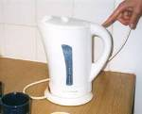
Here is another example of brushing teeth using a step by step guide. It is a good idea to place the step by step guide in view, where it is used.
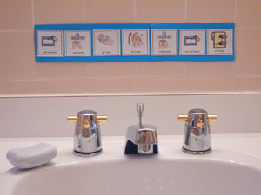

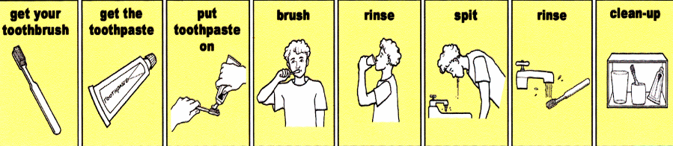

Social stories

It is helpful if your child knows what they are doing each day.

Using simple words such as ‘First’ and ‘Then’ to show a two step sequence.

This will help them understand that something different will happen next.

Picture strips can help with this, or for older children just using the phrase ‘first xxxxxx then xxxxxx’.

First Then

Arrows can help to understand the order of activities. For example at 7.30pm you can have a glass of water then we read a few stories then it is bedtime.


7:30pm

Using visual strips as in this example can help children to follow a sequence. You can make your own sequences using pictures or photos of your child doing the activities.

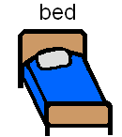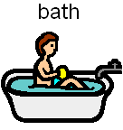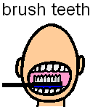

Hand over hand
When a child with autism is learning a skill you may need to physically demonstrate that skill for them. For example just telling a child to wash thoroughly will not work. They need to be shown by you exactly what a proper wash means.

This will often require you putting your hand over their hand and showing them how to wash, brush teeth or put butter on bread. Once they have started to get the hang of it you can reduce the amount of physical prompt and just gently guide them with your hand over theirs. Eventually they may not need any physical prompt from you.

Does he or she know how long each activity lasts?

- Your child may need to know how long an activity lasts.
- They may need a warning of when it will end.
- Try to have a clear start and finish time.

Using visual timers like the ones below may be helpful.

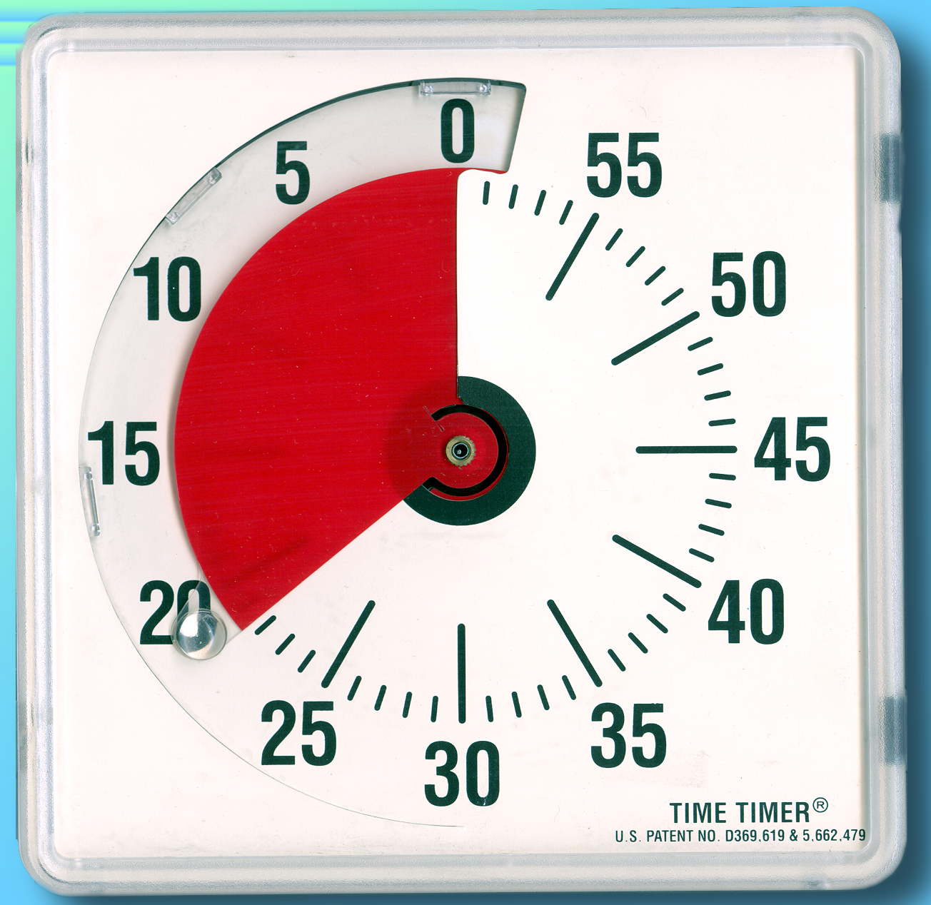
Time Timer
www.taskmasteronline.co.uk

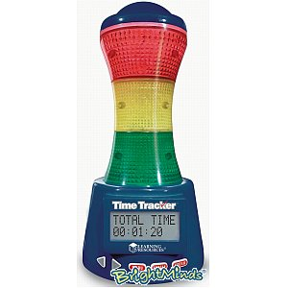
Time Tracker
www.Brightminds.co.uk

Sandtimer www.sensetoys.com

A countdown method may work well as a way of reminding your child something is finishing soon. It is often better to count down and finish on 5-4-3-2-1 rather than count up.

Social stories

- Gives information to your child about the world
- Clear, positive, simply presented wording
- Reinforces the words you speak by your child seeing it in writing

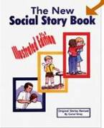

Making mistakes is how we learn
- It is OK to make mistakes
- Everyone makes mistakes
- The cleverest people in the world make mistakes
- If you do not make mistakes you do not learn
- I can correct the mistakes I know how to correct
- I can ask for help with any other mistakes if I choose to
- It is clever and intelligent to ask for help if I make a mistake
- I can practice not worrying about a few mistakes
- I learn from my mistakes

What to say if I lose a game
- I like to play games
- My favourite games are football and basketball
- When I play football and basketball usually one team wins and one loses (unless there is a draw)
- If my team wins I am happy
- If I lose I sometimes do not feel happy
- I can say ‘well played’ or ‘thanks for the game’ to children who are in the other team
- This shows I am mature and a good sport

Schedules
- Helps to develop independence by making things predictable
- Helps person to stay on track and be organised
- Quick and easy to make
You can use timetables and tick lists at home as well.

TICK | TIME | TIMETABLE FOR HALF TERM  Monday | ALTERNATIVES
 |  | Breakfast
 |  | Play on X-Box - 45 mins
 |  | Go to the park | Shops if raining
 | 1pm | Lunch at kitchen table | Lunch at 1.15 or 1.30pm if we stay  at shops a little longer
 |  | Colouring or making - one hour
Play on X-Box - 45 mins
Free play until tea (not X-Box)
 | 5pm | Tea and TV
 |  | Play with dad for 45 mins | TV if dad too tired to play

Tick when done:

Shower

Breakfast

Get dressed to go out

One hour round trip into town

Home for lunch

Afternoon until dinner – computer games

Schedules to prepare for change

Children need to get used to changes. It will help if they know what is going to happen.

Change needs to planned for and introduced carefully so your child does not become too anxious.

- Introduce small changes to their routine.
- Stay in new places for a few minutes at first
- Take photos of places or people

Use a ‘something different’ symbol or card

Wake up | Breakfast | TV | Lunch | Grans   | Shops | Tea

Wake up | Breakfast | Something different  Park!! | Lunch | Grans | Shops | Tea

1 to 5 scales

- Makes something vague into something clear
- Helps child to understand degrees of whatever is being measured

1 to 5 scale to keep on track in conversation

Use hand to indicate conversation flow:

- Thumb up is OK
- Thumb one finger is just be aware you are beginning to take over the conversation (but I can see you have something you need to say)
- Three digits – you are taking over
- Four digits – I will have to ask you to stop talking
- Five fingers upward – stop!

1 to 5 Scale - Voice volume

Voice volume | What it sounds like | When/ where I could use that voice
5 | Shouting | In an emergency
4 | Outdoors voice | At a football match  At break time
3 | Conversation | In the classroom  In the supermarket
2 | Whisper | In the library  At the cinema
1 | No voice | When I need to be quiet or don’t want to talk

1 to 5 scale - Things that make me lose control

1 to 5 scale to say how stressed you are feeling



Cue cards
- Can be used to back up information your child already has been given
- Like a short Social Story
- Convenient and discrete

RELAX

1. Breathe out slowly through your mouth.
2. Breathe in slowly through your nose, so your diaphragm moves out.
3. Pause.
4. Go back to 1.

Repeat five more times.

WAIT!

Please wait while Mum or Dad has a short chat with this person.
Mum and Dad know that I hate having to wait but I can try to stay calm for
2 minutes while they talk.

Flowcharts
- Show visual sequence more clearly than spoken word
- Allow child to discuss different options and likely outcomes

Flowchart to show choices if you fancy a girl:

Flowchart to show a child how when a potential meltdown situation occurs they still have choices to make:

Flowchart to show choices about talking about trains:

I want to talk about trains


Ask mum or dad “Do you want to hear about trains?”

No
Yes
I can talk about
trains for up to 2 minutes
Pause
Go and ask someone else or talk about something else. I can talk about what was good on TV last night, my favourite food, what we will do at the weekend or what we did last weekend
Do you want to hear anymore about trains?
No
Yes

I can talk about
trains for 1 or 2 minutes then talk about something else

House rules, contracts and reward charts

- Makes it clear who is acceptable behaviour and reward systems
- Avoids direct confrontations

House rules

Be kind to each other

- No hitting
- No spitting
- No fighting
- No taking without asking
- No breaking of each others things

Anyone who breaks any one of these rules loses pocket money
Mum or dad are judge of these rules

This example shows how you can create a family reward chart which distributes points according to age and skills. This means your children without autism can still earn points, albeit for achieving different goals eg a teenage daughter gets points for coming home at the right time.
Stick people
- Easy and portable to use
- Helps your child understand other peoples thoughts and feelings

Mind maps
- Uses visual layout to show relationship between different pieces of information
- Easy to draw and portable

Traffic lights

Most children understand the concept of red, amber, green so it makes for an effective and simple way to teach about when things are OK and not OK

Traffic Lights to remind a child of an activity about to end

- Show the green card when an activity is taking place.
- Show the amber card when the activity is near the end.
- Show the red card when it is finished.
Wii finish
(RED)
5 more minutes
(AMBER)
45 minutes on the Wii
(GREEN)


Conversation skills

As well as social skills such as sharing, losing gracefully, accepting others opinion, making a cup of tea for someone else there are numerous skills involved in conversation.

Some of the core skills in having a conversation are:

- What is a conversation?
- Starting a conversation
- Eye contact
- Personal space
- Taking turns in conversation
- Keeping on topic
- Talking about interests
- Sensitive topics
- Ending a conversation

There are lots of books and online resources to teach social skills. Have a look at www.jkp.com and search for ‘autism’ and ‘social skills’. Ask an autism professional if you are stuck.

When you are discussing social or other daily living skills with your child, help them think about:

- What … is the social skill?
- Why … is it worth learning it?
- How … do I do the social skill?
- When … do I use the social skill?
- Try! … use it or lose it!

Conclusion

In this Handbook we have discussed the importance of self esteem, ways to be autism friendly in your communication with your child and also how to assist them develop friendship and social skills.

All of this can be hard work. Give yourself and your child a break and don’t be hard on yourselves. Remember that no time spent helping your child build self esteem and confidence is wasted. Good luck and get further support from your autism professional.

